|  |  |
| --- | --- |
|  | **GST 113**  **NIGERIA PEOPLES & CULTURE** |
|  | Sarah AJIYA  Cordelia CLAYTON  Tobi JOHNSON  Dinatu B. TANKO  Felix ODOFIN  Cynthia M. SAIDU |

|  |
| --- |
| **[© 2019]** |
|  |



**LESSON 4**

**Major Ethnic groups in Southern Nigeria**

**THE IGBO**

The Igbo people are best known for their segmentary or acephalous way of life. This is because from the ancient times, they had no centralized states. Consequently, they operated a kind of government without kings.

Generally, the Igbo are predominantly farmers, traders, and businessmen. Despite some cultural diversity among them, they do share a common basic culture in their language with a cluster of dialects that are mutually intelligible. They also share a common political system based on decentralization of power and delegation of authority exercised by the holders of the staff of authority, the Ofo.

**ORIGINS OF THE IGBO**

The origin of the Igbo people is as controversial as that of the Yoruba and the Bini. There are so many versions and it is very difficult to say which is the most acceptable.

**The Middle East Version**

Some believe that the Igbo peoples migrated to their present location from either the North or the Middle-east.

**The Igboland Centred Version**

Others believe that the Igbo people had been in their present abode from the beginning. Therefore, Igboland is the original homeland.

**The Nri Version**

Professor M.A. Onwuejeogwu (2000) regards the Nri version as the only authentic version of origin in existence in the oral tradition of the Igbo. According to Nri version, the ancestor of the Igbo, Eri, descended from the sky and sailed down the River Anambra. When he arrived at Aguleri, he met some autochthonous group of people who had no living memory of their own and settled with them. As their population increased, some groups migrated to other parts of Igboland to establish their own settlements.

**The Awka or Orlu Version**

Another tradition considered Awka or Orlu towns as the center of origin of the Igbo from where they dispersed to other areas.

**The Idah Version**

Some groups such as the Umunri claim to have migrated to their present location from Idah.

**The Benin Version**

The Onitsha and the Igbo on the other side of the River Niger [Delta Igbo], claim Benin origin.

**The Israeli Version**

One of the most popular versions of the migratory stories of origin of the Igbo people is the one that points to Israel. This assumption is based on the so-called similarities between the cultures of the Igbo and the ancient Hebrew. Some Igbo scholars consider themselves as off-shoots of the lost tribes of the Hebrews who migrated southward.

You should remember that the Igbo society has always been known as acephalous. Moreover, there were very limited professional historians as at that period. There were no equivalents of Oba, and Alaafin or of palaces over most parts of Igboland. This is why it is very difficult to reconcile all these various versions.

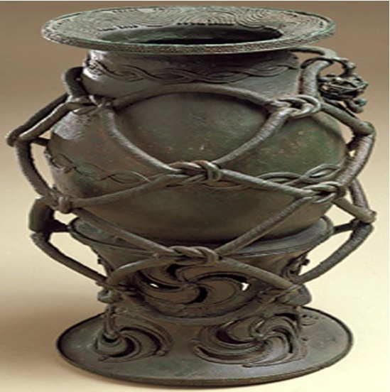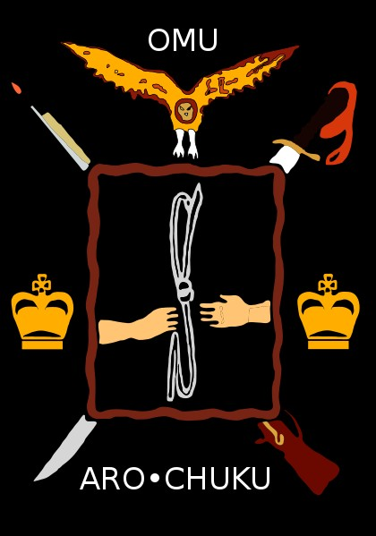

**THE SOCIO-POLITICAL ORGANIZATION OF THE IGBO**

Unlike other ethnic groups such as the Yoruba and the Bini, the Igbo people did not build any strong centralized states. This is mainly because Igbo society had always been fragmentary or acephalous. In traditional Igbo for instance, the village was the centre of government. This has been described as direct democracy. The village-centered administration implied that every linkage for instance, including all male adults in the village, participated in its political process.

**The Amala Oha**

You should always remember that the socio-political organization of the traditional Igbo was fundamentally based either on the age grades or age and titled societies. Amala Oha was therefore a form of general assembly in traditional Igbo society. All the male adult members usually met in this assembly to perform legislative functions. In ancient times, the Amala Oha’s meetings were held in the open village square. All the decisions taken during those meetings were absolute and final. As a democratic society, the life of every individual was highly respected. More so, the recognition of an individual in the society was based on individual capability and age rather than family background. The elders formed the core of village administration. They were highly respected accordingly. Hardworking and wealthy individuals were respected and given important responsibilities in the society as well. The youth, middle age or able bodied men and elders constituted age-sets or age groups. You should remember that each age-set had its own special rights, duties, obligations and responsibilities in matters affecting the village.

i. What do you understand by a segmentary or acephalous society?

ii. The Igbo traditional society has been described as direct democracy. Why?

1. What do you know about the traditional Yoruba, Bini and Igbo peoples and cultures?

2. Discuss any similarity and dissimilarity among them.